|  |  |
| --- | --- |
| The New  “Hello, World!” A new approach to programming Code doesn’t have to be as shown below. It has always been a tradition to display “Hello, world!” on the screen when first starting a code language. We’re going a step forward – We will actually go through each letter. | Learn to Code while having fun playing a game.────Don’t miss the chance to become a programmer────Learn the basics of programming by just completing the game────Play the game NOW!! |

# How to play:

#### Aim –

The aim of the game is to complete a set of ten levels using block (or button) coding,

controlling a red square-shaped robot. Using a combination of Move, Turn and repeat blocks, you must manage to reach the numbers one, two, and three in correct order to complete a level.

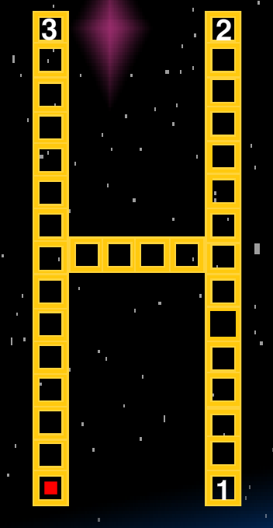

How it feels -

The Picture you can see on the right is one of the 10 levels of the game. If you notice, the yellow grid is actually a grid in the shape of an H. Each level represents a letter. These are the letters, in order -

“H E L L O W O R L D”

Together they form the famous phrase, “Hello, World!”.

The red square is the player and has to reach the white numbers 1, 2 and 3, in order.

#### Controls –

All code blocks and code editing tools are in your coding sidebar. This is a quick view of how it looks.

THE CODER (BLOCKS) -

The six top most blocks are the turn blocks. You can use then to turn your robot 45◦, 90◦ and 135◦ left or right. Just Clicking any of them will add a block to Your current code, the list shown below the blocks. Remember to use these blocks wisely, because direction is always respective to you.

Below the six move blocks is a “Move a step” block. This just moves your robot one step forward in the direction you are facing. The robot always faces up when you begin a level.

The yellow colored blocks are the repeat and close repeat blocks. Once you click a repeat block, you will get a popup asking you how many times you want to repeat.

After you have added a repeat block, you can add any block you want to be repeated the number of times you specified. Then close the repeat block using the “}”. All Blocks between the Repeat and the “}” will get repeated when you run the code.

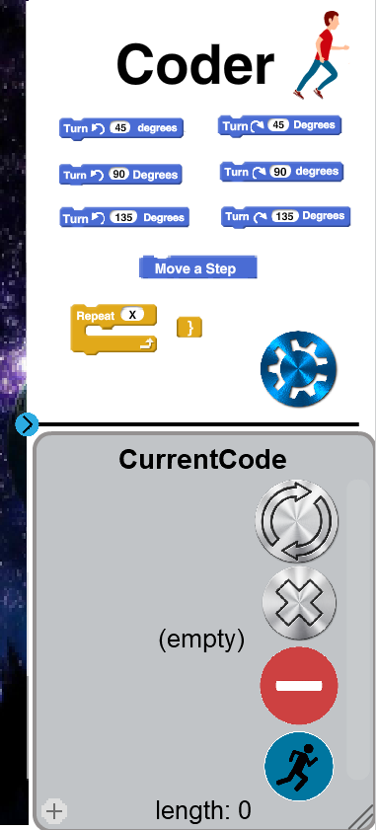

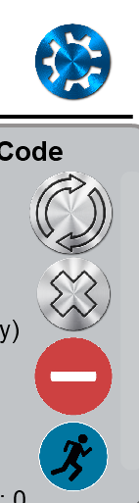

THE CODER (BUTTONS) –

The button on the bottom is the run button. It let’s you run your code and also triggers an animation on the top of your sidebar. The red minus is the remove one button. It removes the last code block from your code. The X above the minus removes all of your code. The Reset Button (the button above the X) resets your players position, but doesn’t delete your code. The Tweak button (GEAR) Let’s you replace or delete any block in your code.

All Controls are also given in the game. The game will also provide the Java equivalent code.

#### For Judges (and anyone interested in how the game was made) –

Here are three features that took me quite a lot of time to make and think through.

1. ADDING Repeat BLOCKS TO THE LIST CURRENT Code

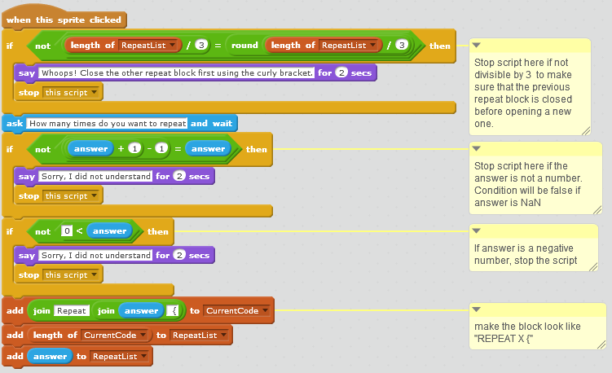

Every time a repeat block is added, two items are added to this list. The first is the location of the repeat block. The second Is the number of times to repeat. Once you close the block, the location of the closing bracket is also added to the list.

This list is invisible to the user.

What is Repeat list?

The First If Statement checks if the number is divisible by three.

The Second checks if it is a number

The Third makes sure that the answer is not a negative number or a zero

Finally, the computer adds this to the code – “REPEAT (NUMBEROFTIMESTOREPEAT) {”

And then as said above, it adds the location of the repeat and the number of times to repeat the repeat list.

1. REMOVING THE CLOSE BRACKET USING THE MINUS BUTTON

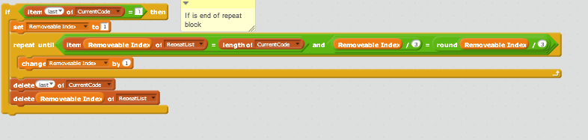

The First If Checks if The Last block is actually a “}”.

Here it is not as simple as just deleting the last code block, as other cases. As mentioned above, adding a

} also adds the location of it in repeat list. So, we must delete both.

The Removeable index is like the int i in other languages, and repeat until the index of the “}” is found.

It also makes sure that the index found actually denotes the end of a block, by making sure it is divisible

By 3 (The Number 3 since the end of a repeat block will always be the third in the repeat list).

Finally, the code deletes both entries, one in each list

1. Execution of repeat blocks

The Blocks are too big to take screenshots, so if you have the source code with you, navigate to the player sprite, then look for the “when I receive run code”, and scroll to the last if statement which is inside the big repeat block, saying “If letter 1 of item code count of current code = r”. Explanation of the code –

When I Hit a repeat block (IF letter 1 of (item current code of code count) = r), set repeat count to how many times I have to repeat (The next index of, along with the set repeat count) , then repeat all the code between the Repeat { and the } Repeat Count Times (The Whole Repeat (Repeat Count) Block). Proceed directly to after the repeat block and do not scan the items inside the repeat block as regular items, preventing one extra repetition (Set Code Count Addition Service & Set Code Count Blocks).

Thank you for playing The new “hello, world”.